21st-century skills
- Creativity
- Creativity occurs through a process by which an agent uses its ability to generate ideas, solutions, and products that are novel and have value (or usefulness) [7]
- To observe Creativity in a classroom, Parameters used in the Torrance Test of Creative Thinking (TTCT), such as fluency, originality, flexibility, and elaboration, have been used.
Behavioural Involvement (Visual) | Verbal (Auditory)
- Involvement in the task (Intrinsic Motivation) [Example: involvement, work on stability, set breaking, and pace planning, and playfulness, exploration, enjoyment, and concentration] | Concrete Focus [Example: talking about the task]
- Exhibited Uncertainty [Example: self-initiated backtracks] | Concept Identification [Example: analogies, "ahas," and transitions. Unexpected changes in thought and sudden inspirations characterised this aspect of the process.]
- Assuredness [Example: confidence, pace, and not encountering difficulty] | Difficulty [Example: problems with self and negative exclamations, characterising individuals who said negative things both about their own abilities and about the task in general.]
 | Wide Focus [Example: goal statements and irrelevant-to-task comments]
 | Striving [Example: difficulty, transitions, questioning how to do something, repeating something, and exclamations (both positive and negative).]

Looking Inside the Fishbowl of Creativity: Verbal and Behavioral Predictors of Creative Performance
John Ruscio , Dean M. Whitney & Teresa M. Amabile Published online: 08 Jun 2010

- For instance, Torrance (1979) used fluency and flexibility as two measures for creativity, which in the novelty hierarchy are represented by ‘many’ and ‘varied’.[1]
- Performance in this activity is scored on three scales: Fluency, Flexibility, and Originality.
- Fluency is defined as "the test taker's ability to produce a large number of ideas with words”.
- Flexibility is defined as "a person's ability to produce a variety of kinds of ideas, to shift from one approach to another, or to use a variety of strategies."
- Originality is defined as "the subject's ability to produce ideas that are away from the obvious, commonplace, banal, or established" (Torrance, 1974b, p. 57) [2]
- Fluency Examples
  - Math-Describe ways to see the number 24 (number sense).
  - Science-List things that require energy.
- Flexibility Examples
  - Science-List beneficial things about fossil fuels, how the British view U.S. reactions to the BP oil spill, or alternate hypotheses for lab inquiry.
- Originality Examples
  - Math-Show 24 as a shape.
  - Science-Create an illustrated lab report from the point of view of one of the chemicals or a Glog of the sights and sounds of a cell’s life.
- Elaboration Examples
  - Math-Explain the steps on a poster or Glog. Decorate 3D shapes to show their dimensions and characteristics.
  - Science-Annotate a diagram or image of an insect, plant, cell, etc.[3]
[1] STUDYING ENGINEERING DESIGN CREATIVITY1 Developing a Common Definition and Associated Measures PRABIR SARKAR, AMARESH CHAKRABARTI Indian Institute of Science, Bangalore, India .p11
[2]A METHODOLOGICAL STUDY OF THE TORRANCE TESTS OF CREATIVITY ROBERT W. LISSITZ AND JOSEPH L. WILLHOFT University of Maryland
[3] Grow Creativity! By Candace Hackett Shively

More Examples
- Please write down as many as possible scientific uses as you can for a piece of glass. For example, make a test tube. (fluency, flexibility and originality)
- If you can take a spaceship to travel in outer space and go to a planet, what scientific questions do you want to research? Please list as many as you can. For example, are there any living things on the planet? (fluency, flexibility and originality)
- Please think up as many possible improvements as you can to a regular bicycle, making it more interesting, more useful and more beautiful. For example, make the tyres reflective so they can be seen in the dark. (fluency, flexibility and originality)
- Suppose there was no gravity. Describe what the world would be like. For example, human beings would be floating. (fluency, flexibility and originality)
- Please use as many possible methods as you can to divide a square into four equal pieces (same shape). Draw it on the answer sheet. (flexibility and originality)
- There are two kinds of napkins. How can you test which is better? Please write down as many possible methods as you can and the instruments, principles and simple procedures. (flexibility and originality)
- Please design an apple-picking machine. Draw a picture and point out the name and function of each part. (flexibility and originality)

Q1: If a teacher is revising (or in preassessment) or asking a question from the previous class, which involves listing things, then should that be called fluency (creativity)? As opposed to the case where the teacher asks a question involving listing things while teaching (rather than preassessment or revision), which prompts a reply where students are answering using their prior knowledge, as opposed to the case where they remember things from the previous class.
Answer:
There is subtle difference between fluency as a component of creativity and fluency as recall or prior knowledge.
From the Torrance Test and the classroom examples:

Fluency (as Creativity)
- Defined as: “The ability to produce a large number of ideas with words.”
- Context: It is about generating ideas or answers, often in novel situations, without a single correct answer.
- Example: "List as many scientific uses for a piece of glass as you can."
Here, students are generating ideas—whether or not they’ve been taught directly—thus demonstrating creative fluency.

Fluency (as Recall)
- Context: When a teacher asks students to list what was taught in the previous class, it becomes more of a memory recall task, not a creativity task.
- Example: "List the steps of the water cycle we studied yesterday."
This shows fluency in remembering, not generating novel ideas.

Question:
If a teacher is revising (or in preassessment) or asking a question from the previous class, which involves listing things, then should that be called fluency (creativity)?
Answer:
No, it should not be called fluency in the creative sense (as used in the Torrance Test of Creative Thinking).
It is fluency of recall or prior knowledge, not creativity—because:
- The answers are already known.
- The task is about retrieving information, not generating novel ideas.

What about when listing happens during teaching (not revision)?
If students are listing things from their own knowledge base, like:
- "What do you know about how plants grow?"
- "What materials could be used to build a shelter on Mars?"
Then it may involve creative fluency, especially if:
- Multiple possible answers exist.
- Students are encouraged to think divergently.

In Summary:
Context | Type of Fluency | Creative?
Listing from previous class (revision) | Fluency of recall | No
Listing during preassessment (prior knowledge) | Depends—if just recall, then | Usually not
Listing during teaching (open-ended, novel use) | Fluency of idea generation | Yes
So, creativity-based fluency requires divergence, novelty, and idea generation, not just memory recall.
Let me know if you'd like a short rubric or example prompts to help distinguish between the two types in your classroom.

7th Science – 8.08
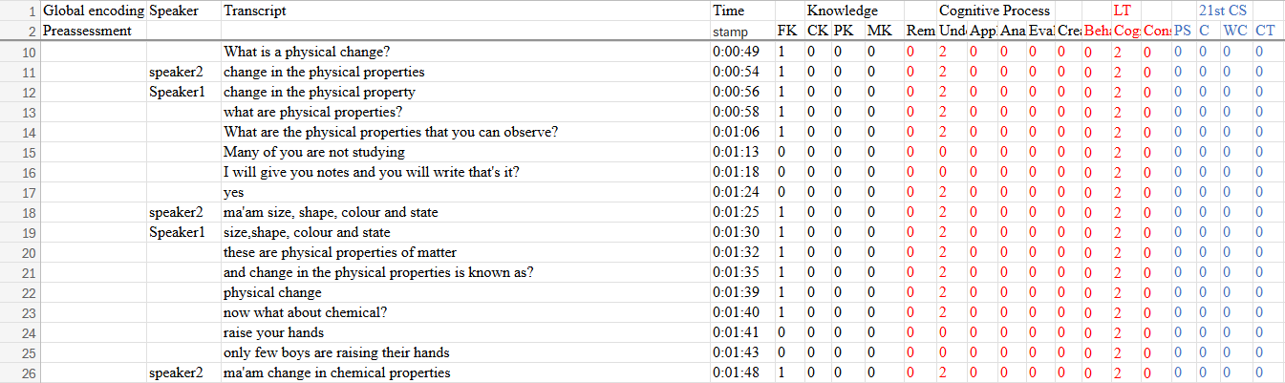
Fluency and flexibility are well‐established components of creative thinking. Fluency refers to generating a large number of ideas, while flexibility means looking at a problem from different angles or perspectives. For example, creativity researchers note that creative individuals “have as many ideas as possible to choose from,” and that fluency (many ideas) and flexibility (shifting viewpoints) are cornerstones of creative thinking. Standard creativity tests (e.g. Torrance Tests) explicitly measure students’ fluency and flexibility in solving open‐ended tasks. In contrast, closed, factual questions tend not to elicit these creative processes. Educational research confirms that closed-ended questions (which expect a single correct answer) are aimed at recall or comprehension, whereas open-ended questions (e.g. “how,” “why,” “what if”) invite elaboration, discussion and creative thinking.
Scenario Analysis
The provided dialogue is a teacher-led review of physical vs. chemical changes. The teacher repeatedly asks for definitions or properties, and the student gives one-word or short-list answers. Key observations:
- The teacher’s questions were closed-ended and fact-based (e.g. “What is a physical change?”, “What are physical properties you can observe?”). Such questions solicit a single correct answer, not multiple ideas.
- The student responded with textbook definitions only: “size, shape, colour and state.” These were standard facts, not novel suggestions. There was no attempt to brainstorm additional examples beyond the expected ones.
- The teacher did not prompt for alternatives or creative elaboration. For instance, she did not ask “How many different examples of physical change can you list?” or “Can you think of a new way to explain this concept?”. Without such prompts, students typically won’t generate extra ideas.
As a result, no creative fluency was evident. The student offered one set of four physical properties – the answer the teacher expected – and then the teacher concluded. There was no “lots of ideas” generation. In terms of flexibility, the student stuck to the conventional viewpoint (listing obvious properties), and the teacher did not encourage any different perspective (e.g. “What if we observed a change in a gas state?” or “How else could we describe colour?”). In fact, the interaction resembled rote learning or recitation, focusing on memorized facts rather than exploration. This aligns with how rote instruction works: it “ensures that facts and answers are remembered” but does not involve deeper understanding or creative thinking.
- No Fluency (many ideas): Only one set of answers given, no brainstorming or multiple solutions. Creative fluency would involve generating many uses or examples, which did not occur.
- No Flexibility (new perspectives): The dialogue remained on the same straight path. The teacher and student did not shift to any “different angle” or new approach.
In fact, the teaching style here emphasises correct factual response. Educational research warns that relying solely on closed questions can limit students’ creative engagement. To foster creativity, teachers are advised to use open prompts that invite multiple ideas or viewpoints. In this scenario, the absence of such open tasks means the conditions for creativity (fluency and flexibility) were not met.

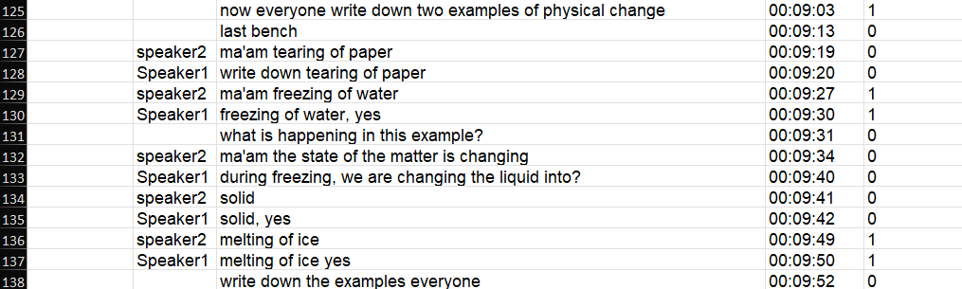
Scenario Analysis
- Fluency (idea generation):
  - Prompt: “Write down two examples of physical change.”
  - Result: Students supplied exactly two textbook examples.
  - Assessment: Because the task cap (two examples) limits idea generation—and because all examples were obvious textbook items—this did not elicit high fluency. A true fluency task would ask for many responses (e.g. “List as many examples as you can in 2 min.”).

- Flexibility (variety of approaches):
  - Prompting: The teacher remained on the single dimension “examples of physical change.”
  - Student responses: All examples were from the same conventional category (common, everyday changes).
  - Assessment: No shift in perspective or strategy was encouraged (e.g. categorizing changes by solid→liquid, liquid→gas, mechanical deformation). Thus, flexibility was not fostered.
Conclusion:
This teaching exchange again centers on fact recall and constrained listing. Neither creative fluency (many ideas) nor flexibility (different ways of thinking) occurred.

Redesign Recommendations to Foster Fluency & Flexibility
Below is a sample redesign, structured as an in-class activity:
1. Open-Ended Brainstorming for Fluency
- Prompt:
“In 3 minutes, list as many examples of physical changes as you can think of—no answer is too silly!”
- Scoring Focus:
  - Fluency: Count of examples per student.
  - Flexibility: Note how many different categories they touch (e.g., phase changes, shape changes, temperature-driven, biological processes).
2. Category Shift for Flexibility
- Phase 1: “Group your examples into at least three different categories (e.g., temperature changes, mechanical changes, dissolution).”
- Phase 2: “Now pick one category and come up with two more unusual examples you haven’t heard before.”
- Why It Works:
  - Students must shift from just listing to organizing their ideas (flexibility).
  - Then they must return to idea generation within a new constraint, deepening both fluency and flexibility.
3. “What If?” Scenario to Stretch Perspectives
- Prompt:
“Imagine you’re on a planet with no air pressure—what new kinds of physical changes might you observe? List as many as you can.”
- Outcome:
  - Encourages students to apply concepts in novel contexts.
  - Forces them to think beyond standard Earth-based examples, boosting both idea quantity and variety.
4. Quick-Write & Share
- Activity:
  - Quick-Write (2 min): Individually list examples.
  - Pair & Share (2 min): Swap lists with a partner and each add three ideas from the other person’s list that weren’t on yours.
- Benefit:
  - Reinforces fluency by adding others’ examples.
  - Introduces flexibility by incorporating different viewpoints.

By moving from a fixed “two-example” task to open-ended, category-based, and ‘what if’ challenges, you create rich opportunities for students to demonstrate both fluency (lots of ideas) and flexibility (shifting approaches)—the very heart of creative thinking in the Torrance tradition.
7th Science – 29.08
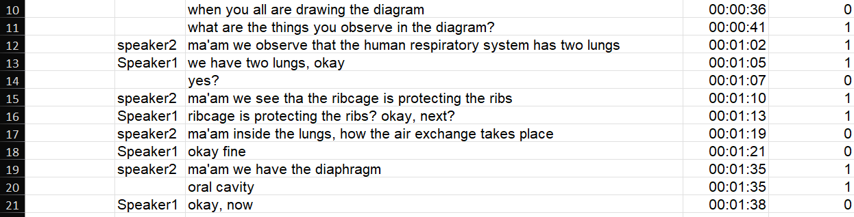
Scenario Analysis
Context: Preassessment activity at the beginning of a chapter on respiration in living organisms.
Teacher prompt:
“Whenever there is a diagram, what are the things you observe?”
“When you are drawing the diagram, what do you observe in it?”
Fluency (Number of Ideas)
- Yes, fluency is present to a moderate extent.
Students volunteered several different components of the respiratory system:
  - Two lungs
  - Ribcage
  - Air exchange inside lungs
  - Diaphragm
  - Oral cavity
→ This shows idea generation: multiple parts/features were mentioned in response to an open-ended prompt.
However, idea generation was somewhat limited in scope. All observations remained close to textbook anatomical labels and basic parts of the diagram.
Flexibility (Variety of Kinds of Ideas)
- Minimal flexibility was present.
All responses were structural or anatomical (e.g., naming parts of the diagram). No students shifted to:
  - Functional descriptions (e.g., “how these parts work together”),
  - Comparative observations (e.g., “this is different in birds or insects”),
  - Aesthetic observations (e.g., “why are lungs drawn that way?”), or
  - Interpretive viewpoints (e.g., “what does this diagram help us understand?”).
→ So, students remained within a single frame of reference, and the teacher did not prompt a perspective shift or new strategy.
Therefore, flexibility was not clearly observed.

Conclusion
Creativity Dimension | Observed? | Evidence
Fluency | Yes (moderate) | 5 distinct anatomical ideas were mentioned.
Flexibility | No | All responses followed a single line of thinking (structural parts). No shift in type or angle of observation.

Redesign Recommendations to Foster Fluency & Flexibility

1. Open Fluency Prompt
Ask:
“Look at the diagram of the human respiratory system. In 2 minutes, list or sketch as many things as you observe or notice—don’t worry if they seem obvious or unusual!”
Why:
- This invites high-volume idea generation.
- Removes fear of being “right” and emphasizes observation.
- Encourages noticing both major and minor details.

2. Flexibility via Observation Categories
After students list things, prompt them to sort or rethink based on categories.
Ask:
“Now divide your observations into at least three types:
- Parts (structures)
- Functions (what each part does)
- Design (how it’s drawn, shaped, or labelled)”
→ This forces a shift in approach, developing flexibility.

3. Creative Variation: Compare & Extend
Ask:
“Imagine you’re an alien creature that breathes something other than oxygen.
- What might your respiratory system diagram look like?
- What parts would change? What new parts might appear?”
Why:
- Encourages flexibility by changing assumptions.
- Invites speculation and divergent thinking.
- Opens the door to fantasy and science integration.

4. Pair Activity: “What did you see that I missed?”
Steps:
- Students exchange observation lists with a partner.
- Each student adds two new items to their partner’s list that they themselves didn’t think of.
Why:
- Promotes more idea diversity (fluency).
- Builds collaborative flexibility by exposing them to different angles.

This scenario shows moderate creative fluency, but no evidence of flexibility. To make preassessments more creative:
- Replace “name a few parts” with “generate as many observations as possible.”
- Ask students to reorganise or reframe their ideas.
- Introduce open-ended, imaginary, or comparative prompts.

Final Operational Coding for Creativity
Type of rules | Problem solving (PS) | Creativity (C) | Collaborative Learning (CL) | Critical thinking (CT)
Decision rules | Encode as PS when activities involve understanding the problem, planning/executing solutions, or monitoring and reflecting on outcomes | Identify utterances, describing fluency and flexibility | Encode utterances that show group planning, shared decision-making, idea sharing, peer support, or reflection on group processes | Code as CT when interactions involve reasoned analysis, evaluation of evidence, inference, argument construction, or reflection on reasoning
Inclusion criteria | - Teacher asks students to solve a problem or prove a theorem  - The teacher asks the student to come to the blackboard and solve a problem  - Identifying and interpreting the given information before solving a problem  - If the teacher/student is giving a reflection from their side while solving a problem | - If the teacher asks to write down/list as many things/improvements/methods, etc., as possible related to the question  - Design and draw a picture and point out the name and function of each part of a machine. | - Group Formation  - Setting clear guidelines and assigning specific roles to students  - Clear task breakdown and resource distribution  - Inviting each student to articulate their reasoning.  - Groups hand over their setup cleanly and prepare for the next  - Students diagnose and correct errors together  - Teacher prompts groups to verify their results before proceeding | - Teacher explicitly identifies or explains the structure of questions and corresponding solution strategies, thereby categorising component parts of reasoning.  - The teacher asks which is correct between options A and B (Comparing)  - If the teacher is telling the meaning, analogies and application in real life of a concept (Clarifying meaning)  - If the teacher is asking a “why” or “because” type of question  - If students are correcting other students or the teacher  - Looking at the problem from multiple perspectives
Exclusion criteria | - Formula derivation/ proof  - Explaining a definition  - MK is occurring | - Write/list down two examples  - Listing closed-ended and fact-based answers from recall | If the teacher explains theoretical concepts prior to conducting the experiment. | - If the teacher is giving a reflection from their side  - Giving/listing as many examples as possible of something  - answering by recalling (single word answers)
Boundary conditions | The teacher asks to devise a plan to do an activity coded as PS | Open-ended prompts to observe and list features in a given diagram are coded as Creativity. | Interactions where the teacher demonstrates and explains an experiment while students observe or follow along, encoded as CL. | - Defining the concept in own words is Und and not CT  - Pure dictation of definitions or prompts to write terms does not count as Critical Thinking

